Pokhara University

Level: Bachelor | Semester – Fall | Year : 2012
Programme: BE |  | Full Marks: 100
Course: Signal System and Processing |  | Pass Marks: 45
 |  | Time : 3hrs.

Candidates are required to give their answers in their own words as far as practicable.
The figures in the margin indicate full marks.

Attempt all the questions.

 | - Determine the Fourier Transform of the rectangular pulse signal defined:  as 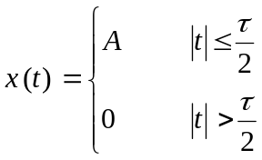  - Define stability of an LTI system. Determine whether the given system is stable or not y(n) = e^{x(n)}. | 8  7
 | - Design a digital Butterworth filter to satisfy the conditions:  0.707≤ |H(e^{jw})| ≤1 for 0 ≤w ≤ 0.2π  |H(e^{jw})| ≤ 0.1 for 0.5 ≤w≤ π Using Bilinear Transformation for T= 1 Sec  - Determine the convolution sum of sequence given below using graphical method.  x(n) = 1 for -1 ≤ n ≤ 1  0 otherwise  and h(n) = 1 for -1 ≤ n ≤ 1  0 otherwise | 8  7
 | - What is the ROC for the Z-Transform? Find the Z-transform and ROC of the given sequence 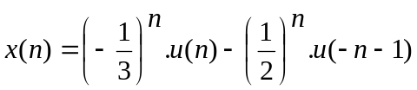  - Given a system  y(n) = 0.5y( n – 1 ) – 0.2y( n – 2 ) + x(n)  - What is the system function?  - Plot the pole-zero diagram.  - Plot the magnitude response. | 7  8
 | - For an FIR filter with co-efficient, K₁=1/2, K₂=1/4, K₃=1. Determine the FIR filter coefficients for the direct form structure.  - Using a butterwort LPF as a prototype design a digital LPF by Impulse Invariance  Method for the specifications given below:  α_{p} = 0.7dB W_{p} = 0.15π  α_{s} = 14 dB W_{s} = 0.6π | 8  7
 | - Explain the IIR filter design by the Bilinear transformation method. In what context this method is suitable over Impulse Invariance Method?  - Compute the circular convolution of the sequences and | 7  8
 | - What is a window function? How can you design FIR filter using Frequency Sampling method?  - What is a Linear Phase Response of a FIR filter? Distinguish between Symmetric and Asymmetric filter. | 8  7
 | Write short notes on any two:  - Sampling theorem  - Radix-2FFT algorithm  - BIBO System | 2×5

